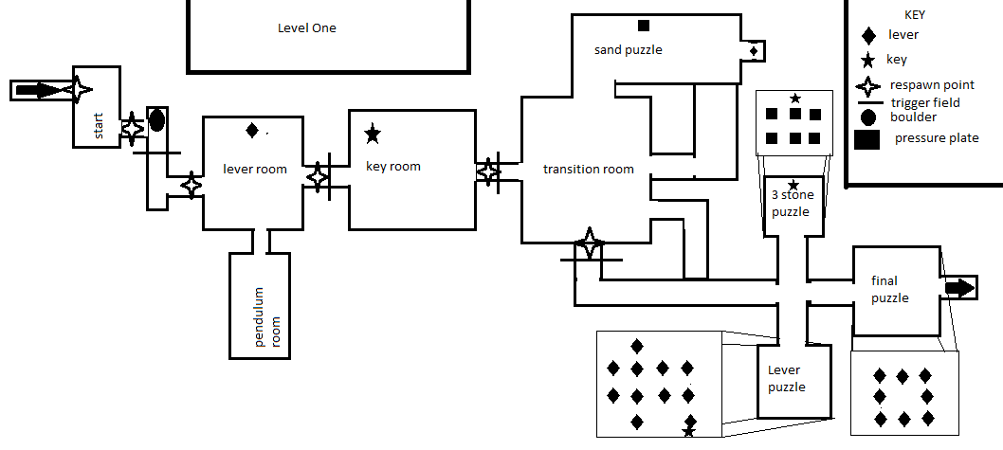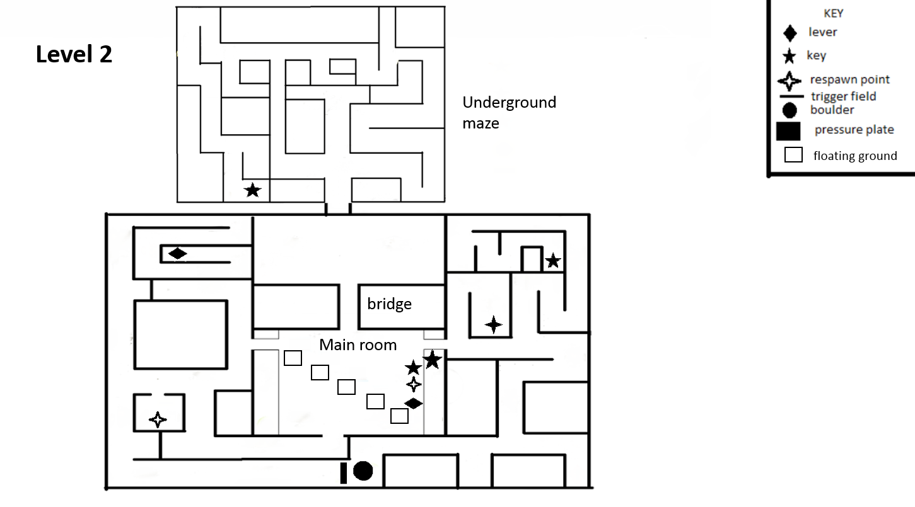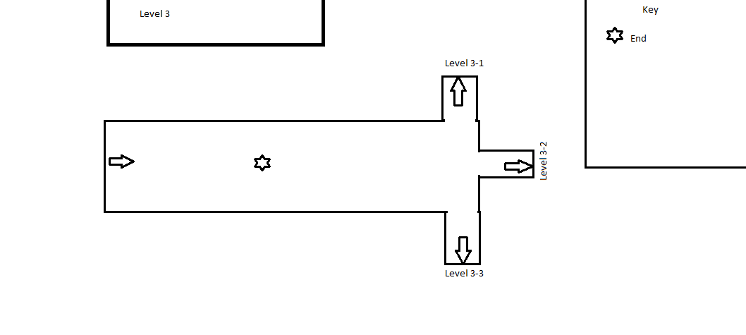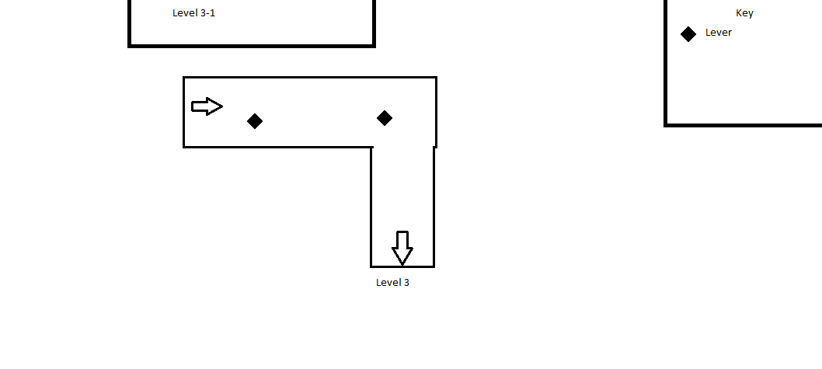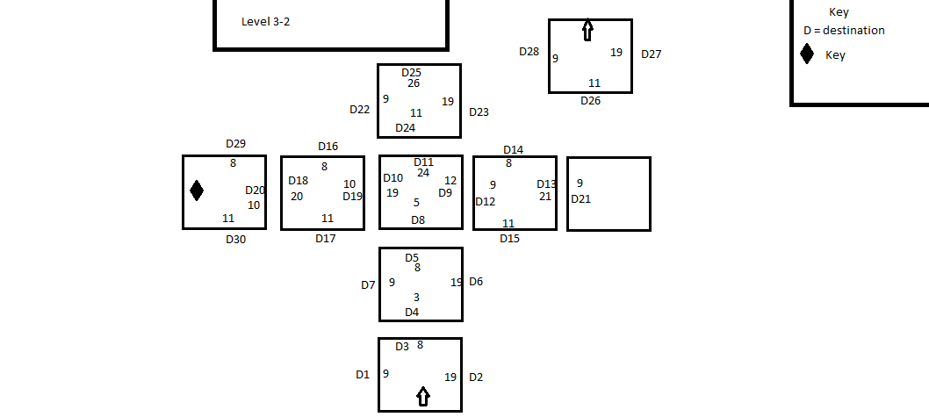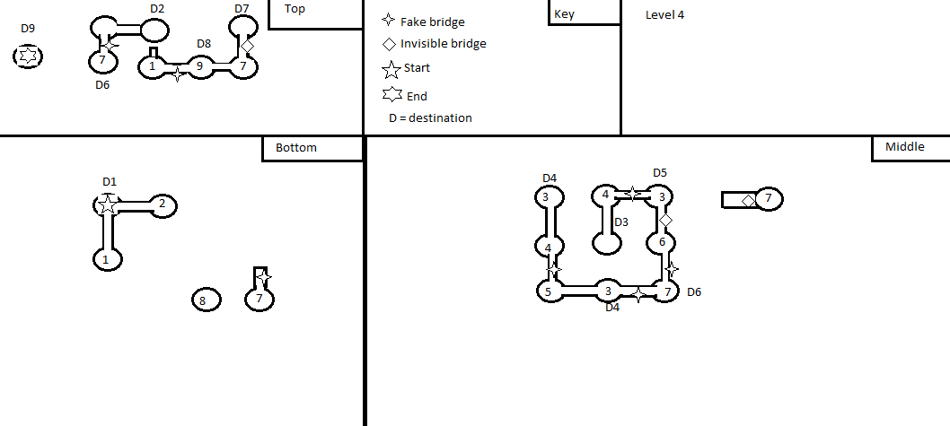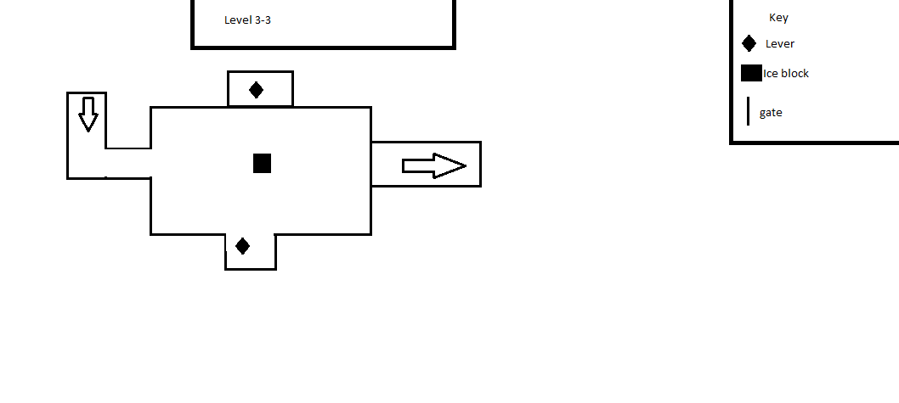

This is basic information regarding this game:

Unity version: 5.3.4f1 //any version of Unity 5 should import it without problems

Information on rut files:

Assets: Meshes and textures and levels go here they are basically anything

unity needs to make the game //warning this directory is a mess

Blender Files: these are some of the blender files for the game and this

directory it used to modify meshes and not mess up the originals

the directory is not used by Unity in any way can can be deleted

Documentation: documentation on the game

Launch_Data: Unknown

Library: Data made by Unity and should never be included in git

obj: Unknown

ProjectSettings: setting for the project

Hidden Files:

.git: where git stores its commits

This is a step by step process on how to get this project started

If git is not required or you already know it then skip to C

A: Getting git set up

1: Go to "github.com"

2: create an account and login

3: go to "https://github.com/MatthewNelson2015/UND-Capstone-Game-2014-2015" //please change this link to yours after you finish

4: Click fork and fork it to your account

5: go to "https://git-scm.com/downloads" and download and install the git for your os

6: then login git in the gui

7: click the + in the top left of the gui and select clone from the tabs on the top

8: then select the correct repository and clone it

B: Making branches in git

1: select the create new branch button which is in the tip left of the gui above the gray area

2: name the new branch and use the from branch to switch what branch you are branching from and then click create new branch

C: Setting up Unity

1: download and install unity

2: open unity and login to your unity account

3: select open on the Unity gui

4: find where you told git to put the game and tell unity that that is the project

5: unity will import all the the assets and this will take a long time

D: Getting to levels

1: Use the navigation in unity which is at the bottom of the gui and labeled project and find assets

2: find the folder scenes in the assets folder

3: double click on the scene you want to open and unity will load it as the current scene

C: editing things

1: select what you want to edit ether from the scene window or from the hierarchy window

2: the inspector window will then be populated with data

3: list of useful components in the inspector window

A: transform; handles how you want to change the object, ie position rotation and scale

B: mesh renderer; handles how the mesh is displayed and material is the texture

C: animator; if the object is animated this is what manages it if there is not a scripted for it (the spiders in level one use a script and an animator)

D: mesh collider; this is very important if it is not there or not on you will fall through it makes it solid (sometime it will not work and then you need to make it convex see the ice block in the iceCave as an example)

E: scripts; they do what you would expect them to do but they cannot be turned off, open them by clicking on the gear and selecting edit script

D: Known import problem

Sometime it will not load all the assets and then the level will only have the torches and thing like that

the levels will not be playable. It is caused by the importer not importing all the assets but it is

unknown how to fix this problem.

To add a new level you must do this:

1: add a new scene

2: do to file build settings then scenes in build and find your scene and click it so it is checked

3: go to the mainmenu level's main camera

4: edit the scpt named menu main

5: in the showLevels function add before EndPage but replace yourScene with the name of your scene

if (GUILayout.Button ("yourScene")) {

SceneManager.LoadScene("yourScene");

}

6: find the script named Endpoint and add a new one it to make your end point

Player Control:

To access player input controls:

1) Open Unity

2) Open Edit dropdown

3) Select Project Sttings

4) Select Input

5) Modify input controls

This will open up the Input Manager. Here you can modify

the current control scheme by changing values within the manager.

To enable xbox support, you must user the alternate button field

and input the corresponding button on the controller using the referances

found on this webpage:

http://wiki.unity3d.com/index.php?title=Xbox360Controller

Virtual Reality Support:

To enable virtual reality support:

1) Open Unity

2) Open Edit dropdown

3) Select Project Settings

4) Select Player

5) Select Other Settings

6) Check the Virtual Reality Supported checkbox

This will enable you to develop the game with the Oculus Rift.

It allows you to test the game in the Editor using the Rift.